Section 1-1 and 1-2 Study Guide 1

Fill in the triangle and write out the four steps to solve the problems.
S
1. Write out the equation – what are you solving for? S = W x F, F = S, W = S
F
W
W F
2. Plug in the numbers with units

3. Do the math
4. Write the answer with the units
Give me an example of a unit of measurement that can be used in your answer for each of the following.
Speed = cm/s m/s mm/s km/s
Wavelength = cm m mm km
Frequency = Hz
If a wave travels at 672 cm/s and has a frequency of 32Hz, its wavelength would be?
21
  - W = S 3. 32 672
F 64
32
32
0
  - 4. W = 21 cm
W = 672cm/s
32HZ

If the wavelength of a wave is 40cm and its speed is 250cm/s what is its frequency?

6.25
- F = S 3. 40 250.00
W 240
100
80
200
200
0
- F = 250cm/s
40cm 4. F = 6.25 Hz

A wave on a guitar has a frequency of 18Hz and a wavelength of 26m. What is its speed?
- S= W x F 3. 26
X 18
208
26
468

- S = 26m x 48 HZ 4. S = 468 m/s

The speed of a wave on a rope is 255cm/s and its wavelength is 30cm. What is the frequency?

8.5
- F = S 3. 30 255.0
W 240
150
150
0
- F = 255cm/s
30cm 4. F = 8.5 Hz

The speed of a wave on a guitar string is 560m/s and the frequency is 28000 Hz. What is the wavelength of the wave?
.02
- W = S 3. 28000 560.00
F 56000
0

2. W = 560 m/s 4. W = .02 m
28000 HZ

Draw a transverse wave and label:
Rest position, amplitude, wavelength, crest and trough
Crest
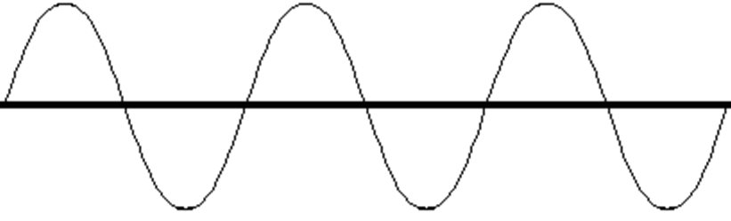
wavelength
amplitude
Rest position
trough
Draw a longitudinal wave and label:
Rarefaction, compression, wavelength
rarefaction
Compression
wavelength

Write the correct word that goes with the following definitions:
- A wave that vibrates the medium at right angles or perpendicular to the direction in which the wave is travels. Transverse wave

- A repeated back and forth or up and down motion. Vibration

- A wave that requires a medium through which to travel. Mechanical wave

- A wave that is the combination of a transverse wave and a longitudinal wave (it occurs at the surface between two mediums). Surface wave

- A disturbance involving the transfer of energy from place to place. Wave

- A wave in which the particles vibrate the medium in the same direction in which the wave travels (parallel). Longitudinal wave

- How far the wave travels in a given amount of time. Speed

- The maximum distance the medium vibrates from the rest position (rest to crest or rest to trough) amplitude

- Material through which a wave travels. Medium

- The number of waves that pass a given point in a certain amount of time. Frequency
- The distance from any point on a wave to an identical point on the next wave. (crest to crest, trough to trough, compression to compression). Wavelength

