



300

What is the angle of reflection? ____________ This is an example of ______________

Below is an example of a ____________ wave

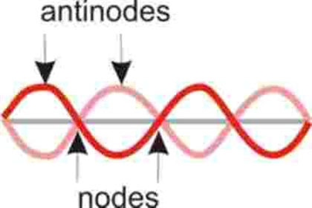

This is an example of ____________________



Draw and label the new waves below



Name ___________________________________________________________________________________

Sound & Light – chapter 1 Study Guide

1. Measure of a wave from the rest position to the crest or trough - __________________________________

2. Where the particles are spread out on a longitudinal wave - ______________________________________

3. The highest part of a transverse wave - _______________________________________________________

4. When two waves combine to make a wave with a larger amplitude _________________________________

5. The bending of a wave around a barrier - ______________________________________________________

6. A wave that is a combination of a transverse wave and a longitudinal wave is a - ______________________

7. Two waves combine to make a wave that is smaller or has zero amplitude - __________________________

8. The number of complete waves that pass a given point in a certain amount of time - ___________________

9. A wave that requires a medium through which to travel - _________________________________________

10. Another word for “to be at right angles” - ____________________________________________________

11. Where the particles are crowded together on a longitudinal wave - ________________________________

12. The bouncing back of a wave when it hits a surface it can’t pass through - __________________________

13. The bending of waves as they enter a new medium - ___________________________________________

14. A repeated back and forth and up and down motion - __________________________________________

15. The interaction between waves that meet - ___________________________________________________

16. The distance from any point on a wave to an identical point on the next wave - ______________________

17. An example of a medium through which a mechanical wave could travel – (you pick two to write down)

____________________________________________________________________________________

18. Material through which a wave travels - ______________________________________________________

19. The lowest point of a transverse wave - ______________________________________________________

20. A disturbance that transfers energy from place to place - ________________________________________

21. How far the wave travels in a given amount of time - ___________________________________________

22. Speed, frequency and wavelength are related by a **mathematical formula**.

**Fill in the triangle and then write out the three formulas below.**

S = W = F =

23. If a wave travels at 336 cm/s and has a frequency of 32Hz, it wavelength would be?

1. 3.

2. 4.

24. If the wavelength of a wave is 40 cm and its speed is 500 cm/s, what is its frequency?

1. 3.

2. 4.

25. A wave on a lake has a wavelength of 1.45 m and a frequency of 7 Hz. What is the speed of the wave?

1. 3.

2. 4.

26. The speed of a wave on a rope is 510 cm/s and the wavelength is 60cm. What is the frequency?

1. 3.

2. 4.

27. The speed of a wave on a guitar string is 630 m/s and the frequency is 9000Hz. What is the wavelength of the wave?

1. 3.

2. 4.

28. A wave on a guitar has a frequency of 28Hz and a wavelength of 16m. What it its speed?

1. 3.

2. 4.

29. When finding **frequency** the **unit** will always be ______________________________

30. Give me three examples of the **unit** answers when finding **speed**. _______________________________

31. Give me three examples of the **unit** answer when finding **wavelength** _____________________________

32. When you decrease the frequency of a wave the wavelength will (increase or decrease) Circle one

Draw two waves below and increase the frequency of one wave to help you figure out the answer

33. In the video we watched on Galloping Gertie, what was it that the wind matched that caused the bridge to start swaying (vibrating) and fall apart? _______________________________________________________

34. Look at the pictures below and tell what type of interference is shown (destructive or constructive), then draw and label the new amplitude of the wave

5

3



1

5

2

3



__________________ Interference _________________ Interference _________________ Interference

35. Name and label the parts of the waves pictured below.

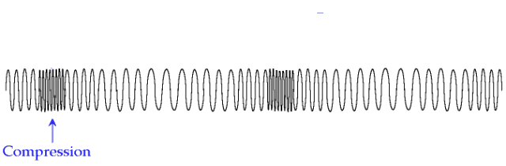 1. _________________________________________ 7. ______________________________

8.

5.

3.

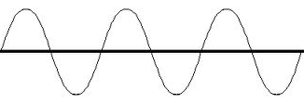

10.

9.

6.

4.

2.

2. ____________________________________________ 8. ____________________________________

3. ____________________________________________ 9. ____________________________________

4. ____________________________________________ 10. ___________________________________

5. ____________________________________________

6. ____________________________________________

Using the numbers on the waves below, write the amplitude and wavelength of each wave – (don’t forget the units)

18 cm

___________________________________________________________________

9 cm

- - - - - - - - - - - - - - - - - - - - - - - - - - - - - - - - - - - - - - - - - - - - - - - - - - - - - - - - - - - -



____________________________________________________________________

0 cm

60 cm



20 cm

40 cm

80 cm

Amplitude __________________________

Wavelength ________________________

45 cm

31 cm

38 cm

52 cm

___________________________________________________________________

35 cm

28 cm

- - - - - - - - - - - - - - - - - - - - - - - - - - - - - - - - - - - - - - - - - - - - - - - - - - - - - - - - - - - -



____________________________________________________________________

21 cm

Amplitude __________________________

Wavelength ________________________