What Are Waves?

Understanding Main Ideas
Answer the following questions in the space provided.

- What happens when a source of energy causes a medium to vibrate?

- What are the types of mechanical waves?

Building Vocabulary Label the parts of the wave shown in the illustration.

3.

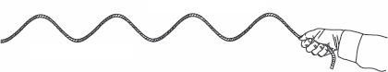

4.

Answer the following questions in the spaces provided.
5. What medium is the wave traveling through?
6. What is the source of energy causing the wave?
7. How do you know the wave is a mechanical wave?
8. What type of mechanical wave is this?
Identify the type of wave shown in each illustration.

9. 10.
What Are Waves?

Waves are all around you, even in plants and animals. Read the passage and study the
diagrams. Then answer the questions that follow on a separate sheet of paper.

Waves in the World Around You
• The cowboy shown in Figure 1 is practicing his rope tricks. The whirling loop of the lasso spins in
a circle just above the ground. As it spins, it develops a kink. This kink is a traveling wave.
• In Figure 2, the plastic frog “jumps” when the spring is compressed and then released. A wave
travels through the spring with each jump the frog makes.
• The garter snake shown in Figure 3 is slithering across the ground. As it moves, two types of
waves pass through its body. When the snake moves forward, its body makes an S-shaped wave.
In addition, contractions ripple down the snake’s body as it slithers along. Muscles underneath
the snake’s skin extend from its head down its body towards its tail. These muscles contract and
relax in a steady pattern in the direction of the arrows. The periodic contraction and relaxation of
the snake’s muscles propel it forward through the grass.

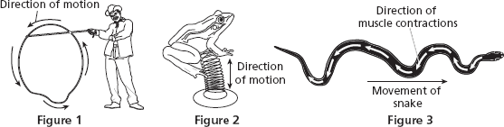

- Does the kink in the lasso travel as a transverse or longitudinal wave? Explain your answer.

The kink is a transverse wave. The kink moves at a right angle or perpendicular
to the direction the loop is spinning.

- What type of wave passes through the spring in the frog toy? Explain.

A longitudinal wave passes through the spring in the toy. Each coil moves in the
same direction or parallel as the wave.

- What type of wave does the snake’s body make as the snake moves forward? Explain your answer.

The snake’s body makes a transverse wave because it curves in a direction
perpendicular or at a right angle to the direction the snake is moving.

- What type of wave do the contractions of the snake’s muscles make as the snake moves forward? Explain.

A longitudinal wave passes through the snake’s muscles. These contractions are
mostly in the same direction or parallel as the movement of the wave down the snake’s body.

- Describe another plant or animal in which you can observe wave motion.

Wind moving through a field of grain can create a series of transverse waves.
A longitudinal wave passes through a caterpillar as it inches forward.

