Name & # _____________________________________________________________________
Properties of Waves
Study the figure below, do the math, then circle the correct answer for each question.

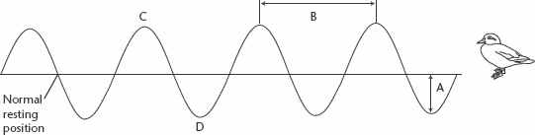

1. In the diagram above, four complete waves pass the duck in one second. The frequency of
this wave is . (no math – just answer the question)
a. 8s b. 4cm
c. 4Hz d. ¼ Hz
2. If this wave travels at 16cm/s, its wavelength would be (do the math)
(use your answer from #1 and show your work/math)
a. 2cm b. 16cm
c. 64cm d. 4cm
3. If the wavelength of the above wave is 2cm, its speed would be (do the math)
(use your answer from #1 and show your work/math)
a. 16cm/s b. 14cm/s
c. 2cm/s d. 8cm/s
Building Vocabulary
Fill in the blank to complete each statement
4. The letter A in the figure above represents the __________________________ of the wave.
5. The letter B in the figure above represents the __________________________ of the wave.
6. The letter C in the figure above represents a(n) _________________________ of the wave.
7. The letter D in the figure above represents a(n) _________________________ of the wave.

- Write out the equation for what you are solving for:
S = W x F W = S F = S
F W
- Plug in the numbers with units
- Do the math
- Write out the answers with the units
Speed units would be m/s, cm/s, m/s
Wavelength units would be m, cm, m S
Frequency units is always Hz
- Fill in the triangle to help you solve the following problems.

- A wave on a lake has a wavelength of .80m and a frequency of 2Hz. What is the speed of the wave?

- 3.

- 4.

- The speed of a wave on a rope is 75cm/s and its wavelength is 5cm. What is the frequency?

- 3.

- 4.
- A wave has a wavelength of 25mm and frequency of 7Hz. At what speed does the wave travel?

- 3.

- 4.

- The speed of a wave on a guitar string is 160m/s and the frequency is 8,000Hz. What is the wavelength of the wave?

- 3.

- 4.

- The speed of a wave in the ocean is 200m/s and the wavelength is 200,000m. What is the frequency?

- 3.

- 4.

- A wave on a guitar has a frequency of 12Hz and a wavelength of 50m. What is its speed?

- 3.

- 4.

